To,
The Heads of the Institutions
UNACADEMY BHOPAL
Dear Sir ,
I am writing to propose an innovative program for school admission (Dummy ) that I believe will benefit your student in a variety of ways and also increase the new admission in your institute. I believe that these services will help your students to excel academically, socially, and virtually and score more marks in boards
We are dealing in school admission regular mode (Dummy Admission know as Virtual School Admission ) for the class 9th to 12th class for PCM or PCB subject. Because we believe that if student engage in full time preparation for the IIT-JEE , NEET , KVPY , NTSE, NSTSE or other competitive exam than school support must with them.
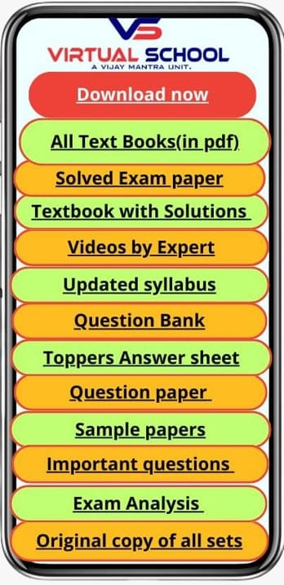
We are working since 13 years in same segment and still we are working with UNACADEMY Indore center that goes up level. There are so many school connected with us with this program and support us for the student attendance , practical ,marks, local examination , and the most important less fees offer to student. we also keep the information very confidential to other competitors.
We offer free virtual app to all the student so that they get all NCERT syllabus on figure tip you can see the contain develop for the board level that give an extra benefit to them and get the good score in boards ( MP board , CBSE board )
More details you can also check our website www.myvirtualschool.in
For more details kindly give us your valuable time to discuss more about the program, I look forward to the possibility of collaborating with you.
Thank you for your consideration.

Best Regards,
Virtual school (VM Eduvanture )

